**IS590DT Assignment3**

**yuweic3 2017/9/12**

**Step 1:**

Select AddExpression filter, and input the following expression to get X1, X2 … and X7.

* The expression of X1:

-E ifelse (((a6 > 1 or a2 < 1000) and (a7 > 1 or a3 < 1000) ), 1, 0 )

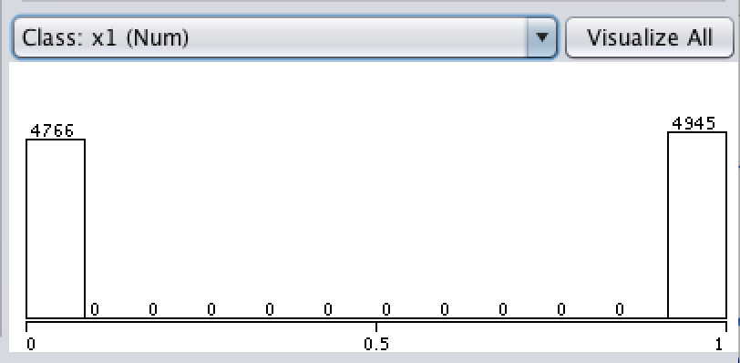

It is clear that there are 4766 X1 features equal to 0 and 4945 X1 features equal to 1.

* The expression of X2:

-E “ifelse(a8 > 0 and a8 <=99999,1, ifelse(a8 = 99999,0.5, 0) )”

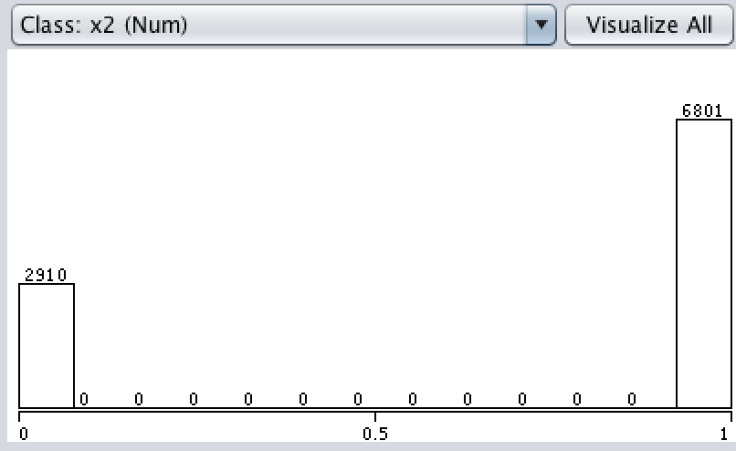

It is clear that there are 2910 X2 features equal to 0 and 6801 X2 features equal to 1.

* The expression of X3:

-E "ifelse ( ((a6 > 1 or a2 < 1000) and (a7 > 1 or a3 < 1000) ), 1, 0 )"

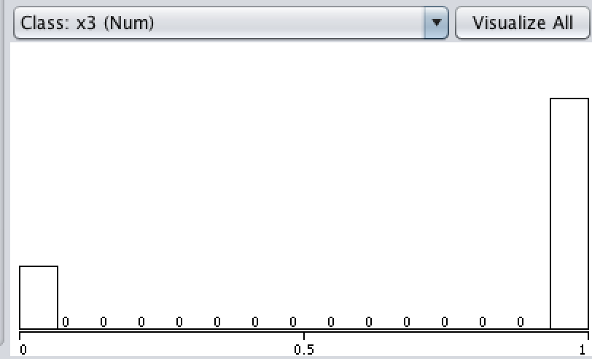

There are 2058 X3 features equal to 0 and 7652 X3 features equal to 1.

* The expression of X4:

-E "ifelse(a10<0.3, a10, 0.3)"

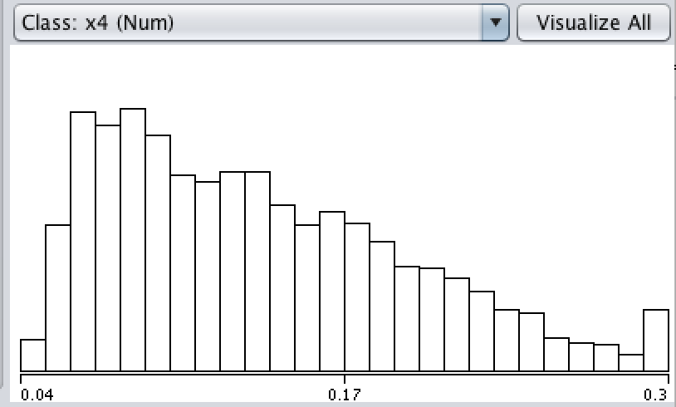

* The expression of X5:

First, we need to use “NumericTransform” to preprocessing to data by applying logarithmic function to “n in MDELINE”, then set attributeIndice to 11 and methodName to log10.

Then we use Addexpression with expression as

-E "- (abs(log(a11)) - 3)"

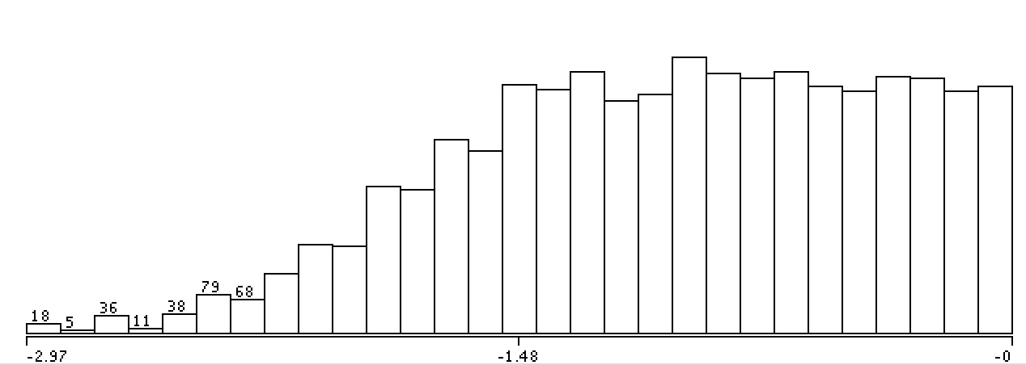

* The expression of X6

Eifelse(1950 > ifelse(2005<a12,2005,a12),1950, ifelse(2005<a12,2005,a12))-Nx6 (9711 instances)

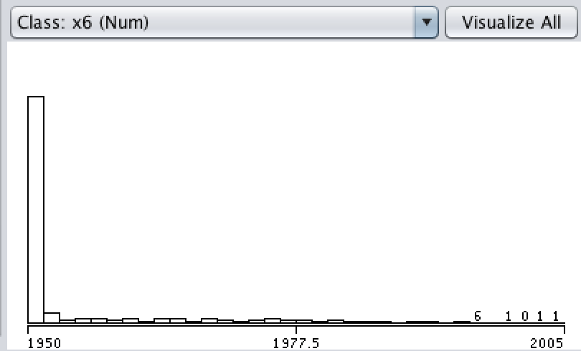

* The expression of X7

Similar to X5, first we use Addexpression to create a new parameter

PAC’= PAC + 0.000000001

then apply logarithmic function “NumericTransform” to “PAC’”by setting attributeIndice equal to the index of PAC’ and methodName equal to log10.

Finally, continue to use Addexpression with the expression of

-E ifelse(8 < -log(a13+0.000000001), 8,-log(a13+0.000000001))

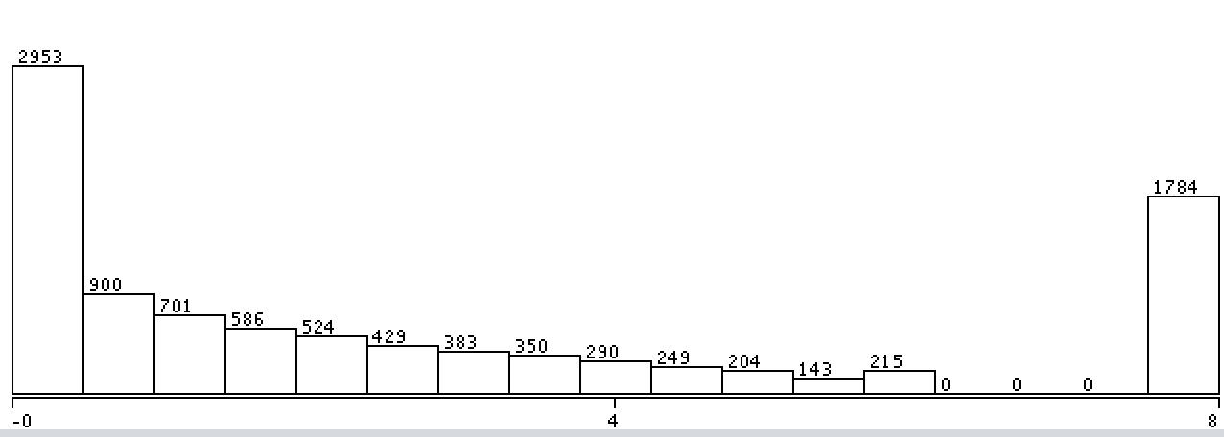

**Step 2:**

Select NumerictoBinary, and apply it to ArrowSmith attribute. Specifically, set attributeIndices = 1

In this way, we decompose ArrowSmith into 6 subparts.

“NomialToBinary –R 1”

Then we get

* I1 = Arrowsmith search = retinal detachment vs aortic aneyrsm

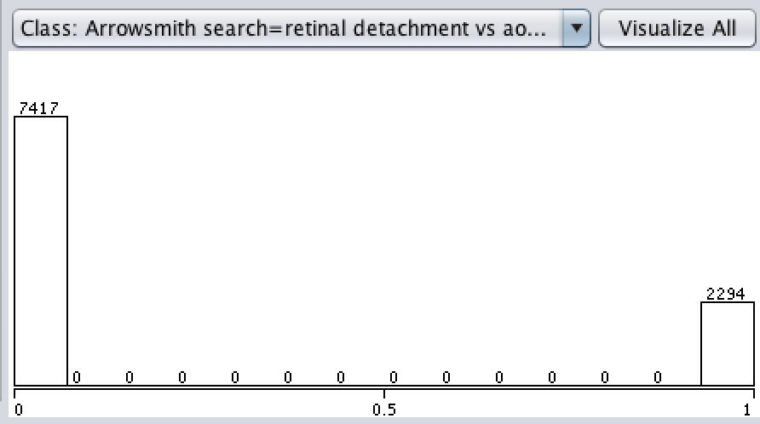

* I2 = Arrowsmith search = NO and mitochondria vs PSD

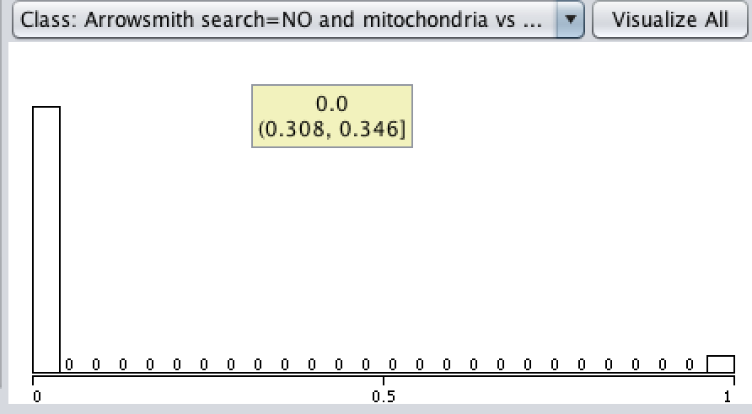

* I3 = Arrowsmith search = mGluR5 vs lewy bodies

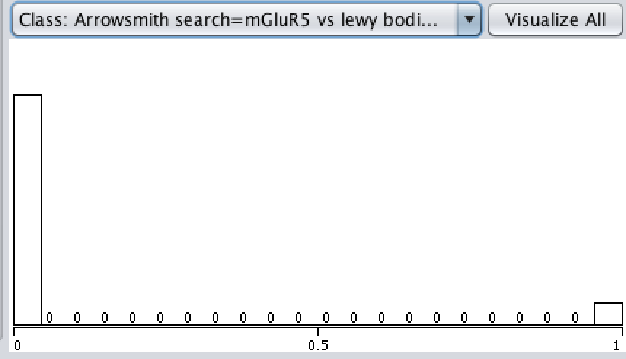

* I4 = Arrowsmith search = magnesium vs migranine

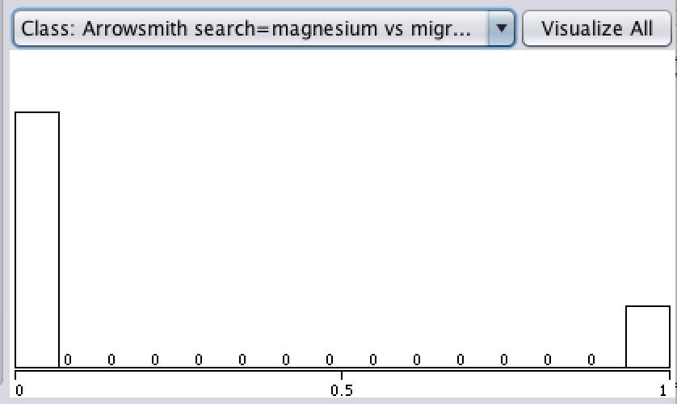

* I5 = Arrowsmith search = Calpain vs PSD

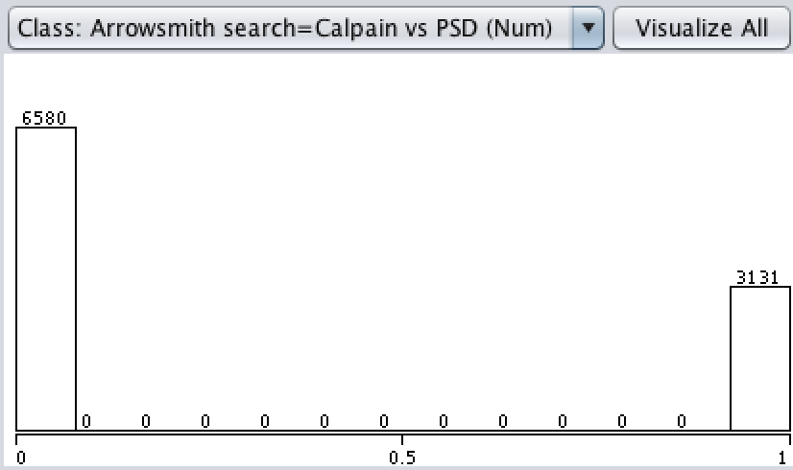

* I6 = Arrowsmith search = APP vs reelin

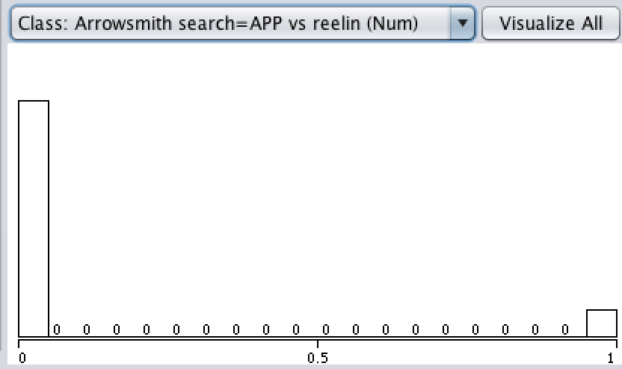

* The expression of Y

“ifelse(a10 = 0 or a10 = 2,1,0)”

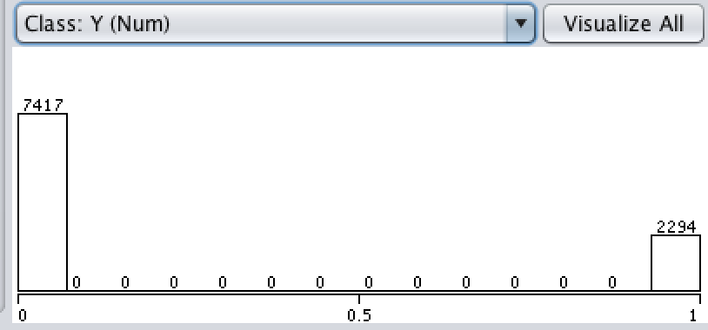

After applying ArrowSmith to target, we have 7417 Y features equal to 0 and 2294 Y features equal to 1.